**Id code: 19CM029 Name:** Dhiraj M. Jagtap Sem: 5th

**Practical No: 9**

**Aim:** Develop a simple application toa.

a. Enter data into database.

b. Retrieve and present data from database.

**Procedure:**

In this practical, we are going to store data in database which is submitted through HTML form.

**Requirements:**

Attention reader! Don’t stop learning now. Get hold of all the important HTML concepts with the [Web Design for Beginners | HTML](https://practice.geeksforgeeks.org/courses/web-design-html?utm_source=geeksforgeeks&utm_medium=article&utm_campaign=GFG_Article_Bottom_HTML) course.

* [XAMPP Server](https://www.geeksforgeeks.org/how-to-install-xampp-on-windows/) (Web Server)
* [HTML](https://www.geeksforgeeks.org/html-tutorials/)
* [PHP](https://www.geeksforgeeks.org/php/)
* [MySQL](https://www.geeksforgeeks.org/sql-tutorial/)

HTML form: First we create an HTML form that need to take user input from keyboard. [HTML form](https://www.geeksforgeeks.org/html-form-tag/) is a document which stores information of a user on a web server using interactive controls. An HTML form contains different kind of information such as username, password, contact number, email id etc.

The elements that are used in an HTML form are check box, input box, radio buttons, submit buttons etc. With the help of these elements, the information of a user is submitted on the web server. The *form* tag is used to create an HTML form.

[**Database Connection**](https://www.geeksforgeeks.org/php-database-connection/)**:** The collection of related data is called a database. XAMPP stands for cross-platform, Apache, MySQL, PHP, and Perl. It is among the simple light-weight local servers for website development. In PHP, we can connect to database using localhost XAMPP web server.

1. **Enter a data into database**

**Program:**

<?php

$servername = "localhost";

$username = "root";

$password = "";

$database = "darkkweb";

$conn= mysqli_connect($servername,$username,$password,$database);

if(!$conn){

    die("Error connection Not successful!");

}

else{

    echo "connection is successful";

}

$sql = "INSERT INTO `hackers`(`Unicode`, `Name`, `Age`, `Salary`) VALUES ('02','Dhiraj','35','35000')";

if (mysqli_query($conn,$sql)){

 echo "successful";

}

else

{

    echo "Not Successful";

}

mysqli_close($conn);

?>

**Output:**

On web site:



On database:

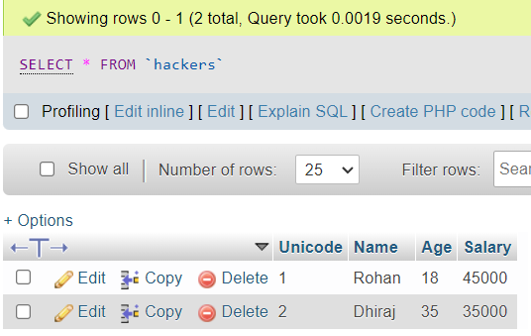

1. **Retrieve and present data from database.**

**Program:**

<table border="1">

    <tr>

        <th>UID</th>

        <th>NAME</th>

        <th>AGE</th>

        <th>SALARY</th>

    </tr>

<?php

$servername = "localhost";

$username = "root";

$password = "";

$database = "darkkweb";

$conn= mysqli_connect($servername,$username,$password,$database);

if(!$conn){

    die("Error connection Not successful!");

}

else{

    echo "connection is successful";

}

$querry = "INSERT INTO `hackers`(`Unicode`, `Name`, `Age`, `Salary`) VALUES ('04','Ajinkya','37','50000')";

$result=mysql_query($conn,$querry);

while($row= mysqli_fetch_assoc($result))

{

?>

<tr>

    <td><?php echo $row['Unicode']?></td>

    <td><?php echo $row['Name']?></td>

    <td><?php echo $row['Age']?></td>

    <td><?php echo $row['Salary']?></td>

</tr>

<?php

}

?>

Ouput:

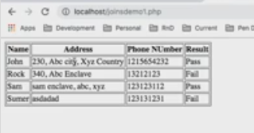

**Conclusion:** Hence I have studied about how to connect data and how to retrieve data from database.